TV Playlist App

Developed and Documented by Michael Genson

Table of Contents

Overview 1

Prerequisites 2

Configuring the app 3

Building a playlist 4

Advanced usage 6

# Overview

The TV Playlist app is a special-built tool to emulate the feel of a live TV broadcast. It generates playlists in .m3u format to be played by your preferred media player (such as VLC). The general structure of the playlist is as follows:

1. Part I of episode 1
2. 1+ random commercials
3. Part II of episode 1
4. 1+ random commercials
5. …
6. Part I of episode 2
7. 1+ random commercials
8. …

The number of episodes, episode parts, and commercials is configurable.

# Prerequisites

1. A directory for each episode.
2. At least one video file for each episode in its directory.
   * optional: the episode may be divided into two or more parts – they should be in alpha-numeric order within the episode’s directory
3. A single directory with one or more video files of commercials. For optimal experience, this should contain as many commercials as is practical.
4. The TV Playlist App.
5. VLC media player or other preferred media player (optional).

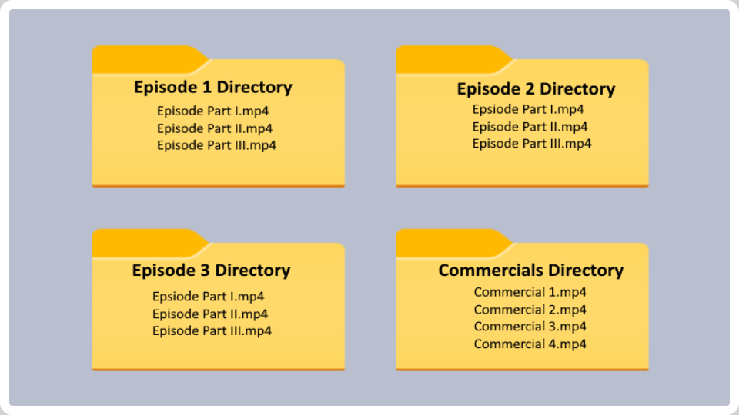See below for a diagram of the correct folder structure:

*\*while the .mp4 filetype is pictured, any valid video format will work*

# Configuring the app

Upon launching the TV Playlist App for the first time, you will be asked to select the commercials directory. Navigate to your directory and choose “select folder”:

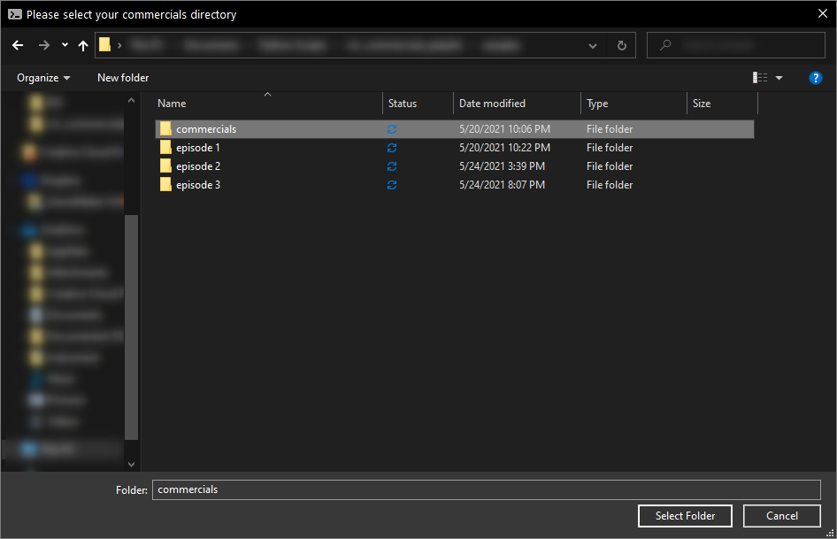

*\*this directory can be changed at any time within the app through the “settings” page*

Once the commercials directory is chosen, you will be taken to the main menu. From here, you may change your settings, or build a new playlist.

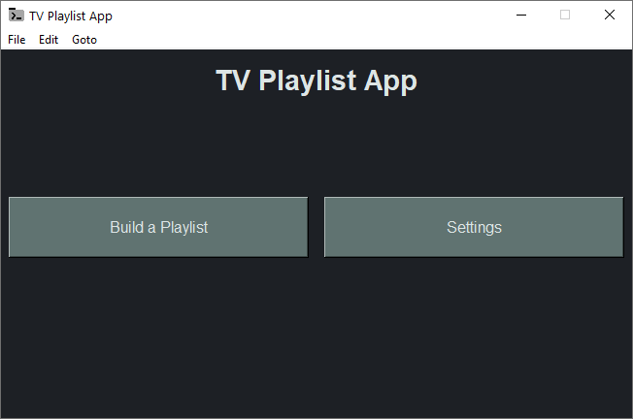

# Building a playlist

To build a playlist, first navigate to the Playlist Builder by clicking the “Build a Playlist” button on the main menu.

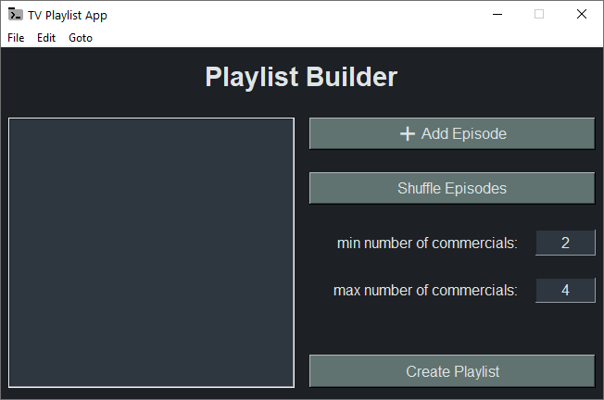

To begin, add any episodes you’d like to add to the playlist by clicking the “Add Episode” button. You may add as many episodes as you’d like, but you must add at least one.

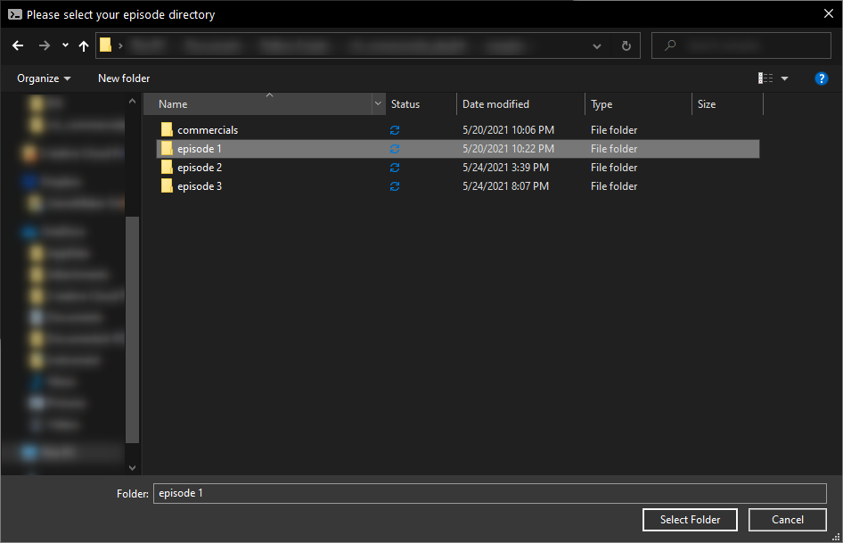

*\*remember that your episodes are contained in directories, so you must choose the directory where your episode files are contained. For more information, see the “Prerequisites” section*

Once your episodes have been added, you may rearrange them by dragging and dropping, or shuffle them by clicking the “Shuffle Episodes” button. You may also select an episode, then right-click to delete it.



You may also modify the number of commercials to be inserted between each part of each episode. A random number of commercials between the min and max will be inserted.

Once you have finished customizing your playlist, click “Create Playlist” and your playlist will be generated. If you have VLC media player installed, it will automatically open your new playlist in VLC. Otherwise, you must select your media player manually.

*\*if you’d prefer to use a different media player, you can override the setting – see the “Advanced usage” section for more info*

# Advanced usage

For advanced users, you may wish to navigate the different menus using the menu-bar or by pressing each menu’s hotkey. To access the hotkeys, mouse over the different menu options at the top of the window (“File”, “Edit”, etc.).

In addition to the menu shortcuts, there are two unique menu options not found elsewhere in the app:

1. Open Playlist – if you previously generated a playlist that you’d like to re-use, you may browse for it using this option. By default, only your 15 most recent playlists are saved. This may be changed by directly editing the config file in your App Data directory.
2. Change Playback Directory – if you prefer to change your preferred media player, use this option to browse to its executable (.exe) file. When opening a playlist, the app will prefer this executable over VLC.